Evolent Assignment

1. As per the given requirement in the document, I have created Git repository for the project. URL for the repo:   
    <https://github.com/SinghPritamFzr/EvolentProject.git>
2. created the new web API project in the .net 6 framework and Added the CRUD endpoints for employee

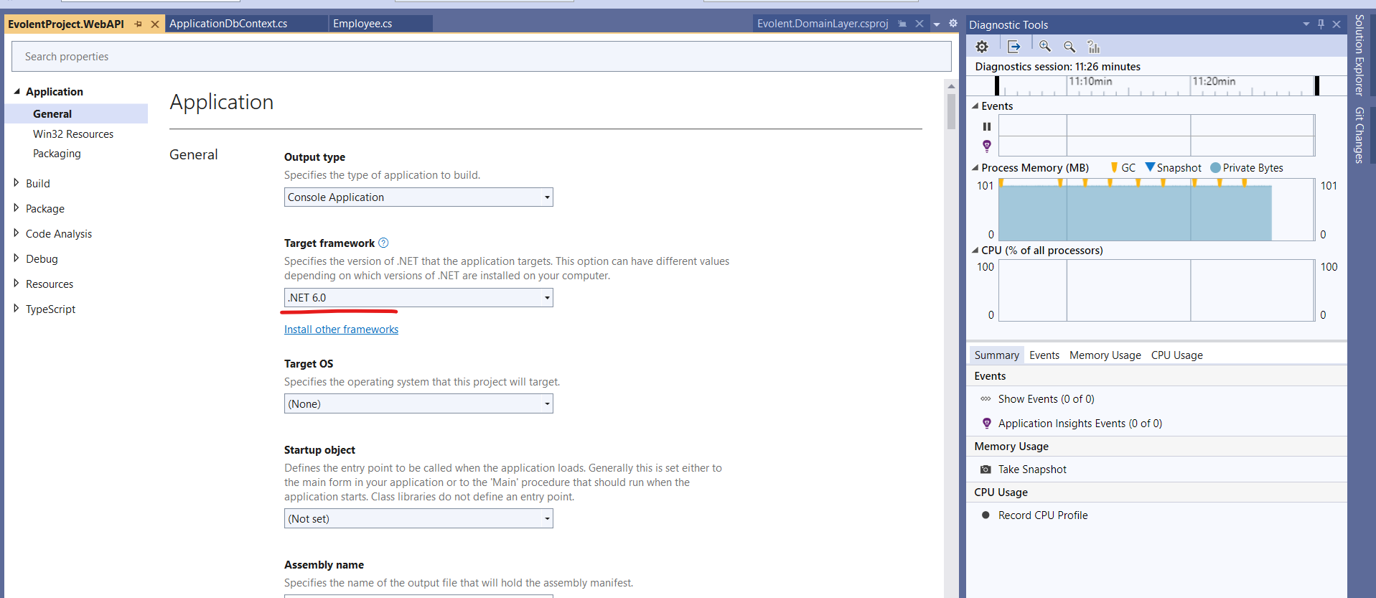

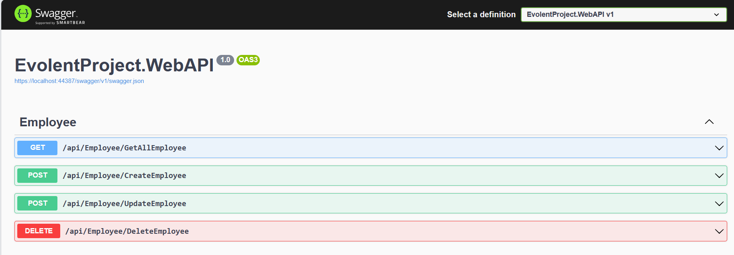

1. Created the required class model for employee entity and added the unique key constraint to check uniqueness for firstname, lastname and emailadress fields. This approach only works in code first migration entity modal. In this project, we are using code first and use in-memory sql database. To enable the code first approach need to uncomment the code in ApplicationDbContext -> OnModelCreating and a few changes in program.cs. By default we are using use sql in memory.

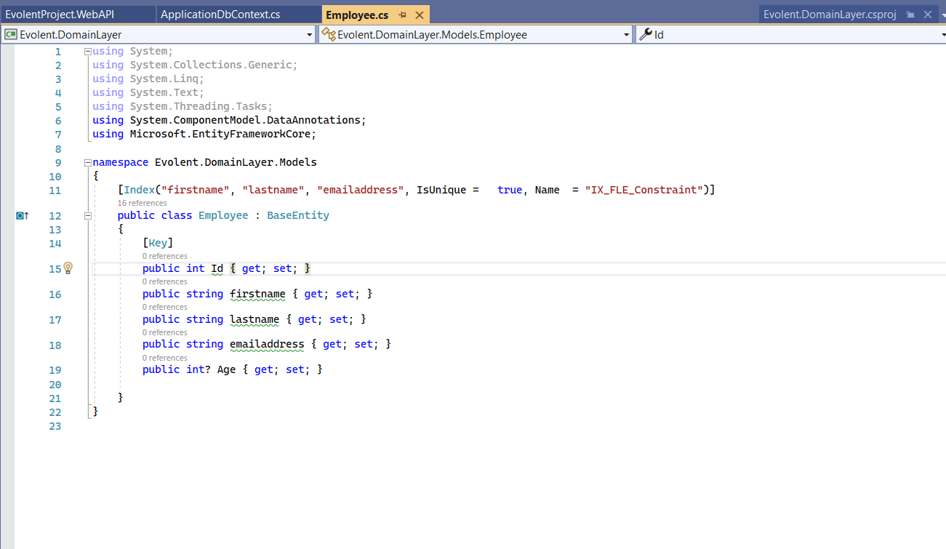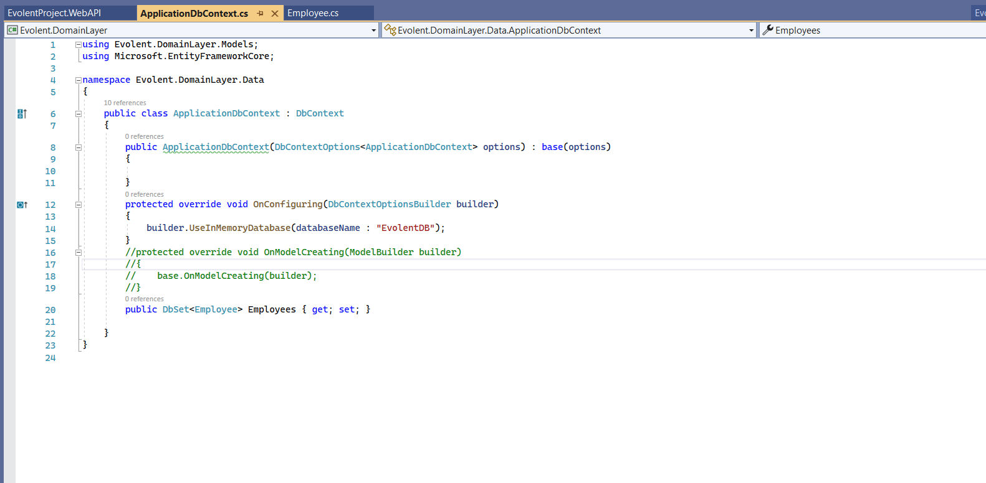

1. To Design this app , We are using a repository pattern (Onion Architecture). We created four layers for project.
2. **EvolentProject.WebAPI**
3. Evolent.ServiceLayer
4. Evolent.RepositoryLayer
5. Evolent.DomainLayer
6. We have resolved the dependency on all layers in the program.cs

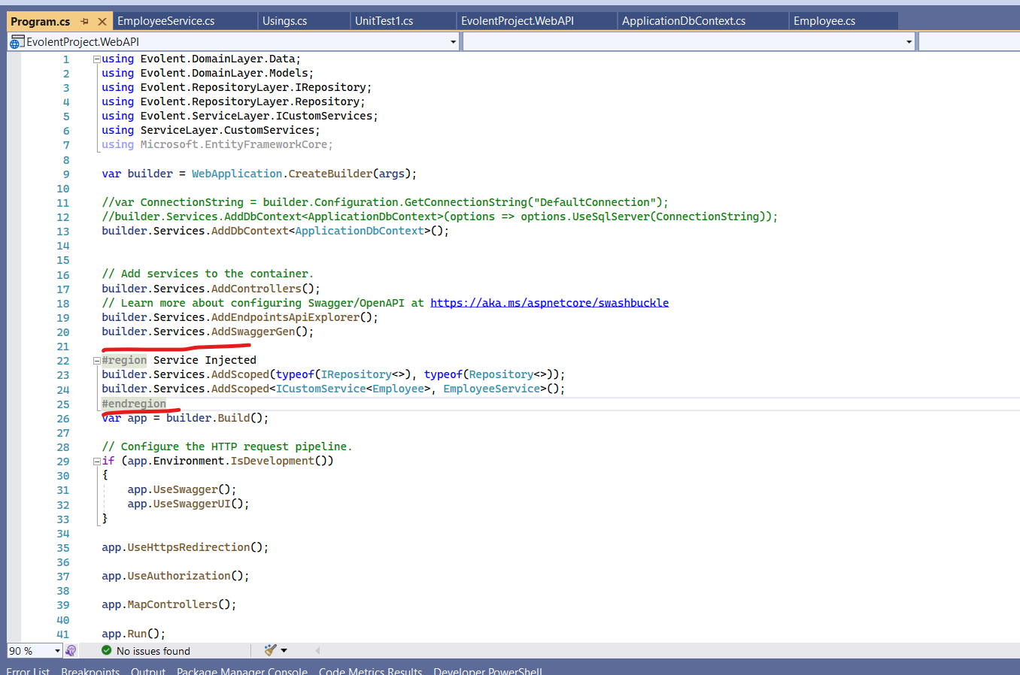

1. And Added the NUnit test project to TDD

